Google Search Trends Analysis | Python Project

- Defined dynamic keyword input to enable multi-topic analysis.
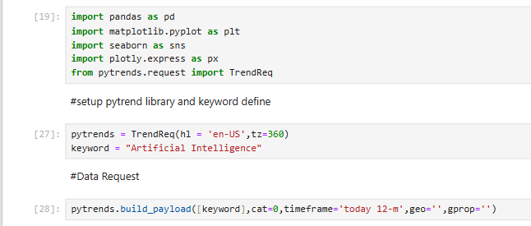

- Identified Top 15 countries with highest search interest using Google’s normalized index (0–100 scale).
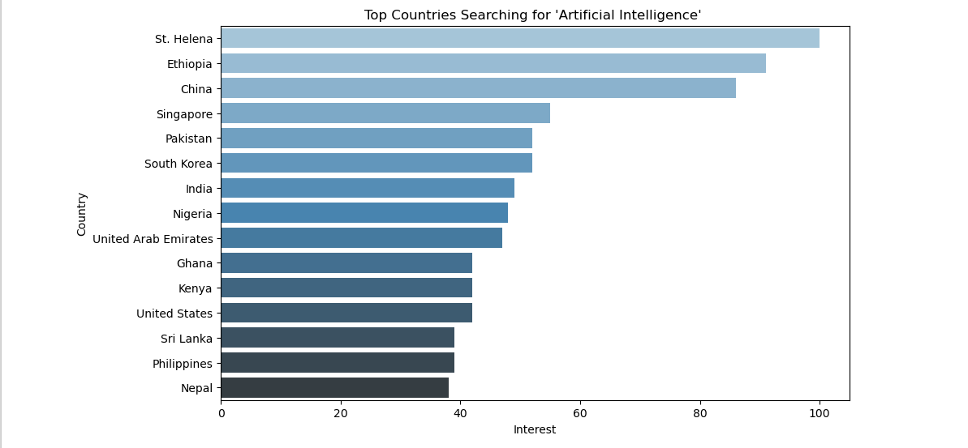

3. Built geo-visualization (world map) to highlight regional keyword dominance.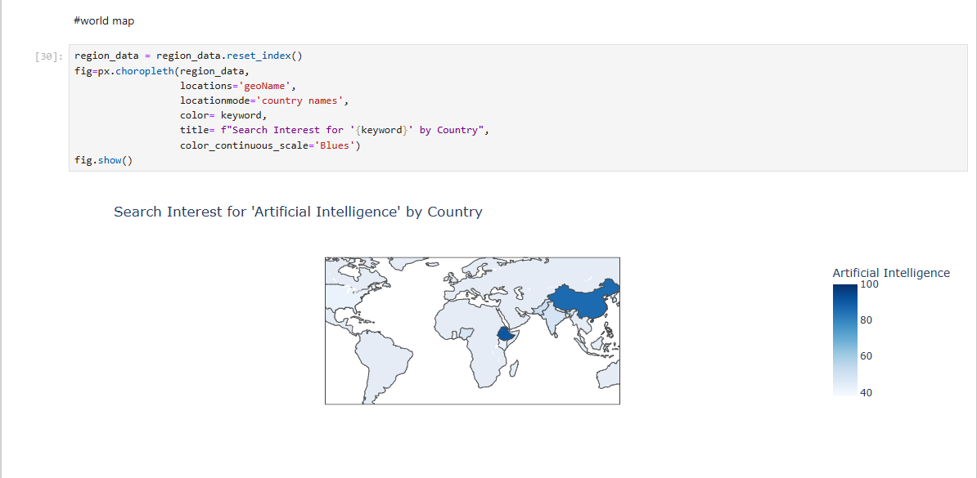

- Performed time-series analysis to evaluate yearly search trend fluctuations
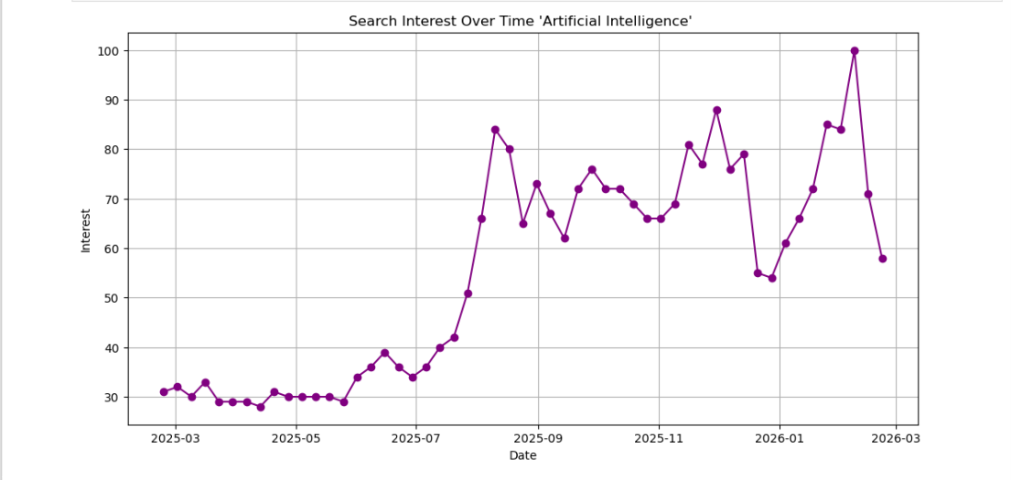

- Compared related keywords and visualized relative popularity using comparative graphs.

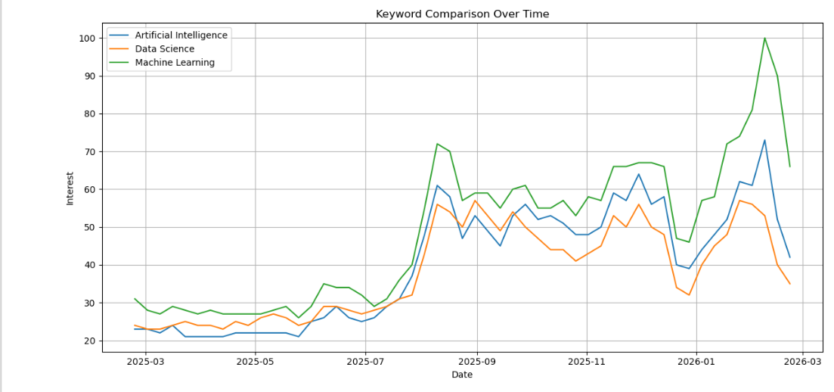

- Implemented complete workflow using Python (Pandas, Matplotlib, Seaborn, Pytrends).

